Chapter 7, Problem 51.

Rather than applying the short-cut technique used in Section 7.6, use KVL to obtain Eq. (7.60).

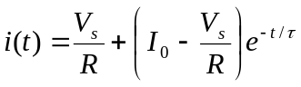 (7.60)

